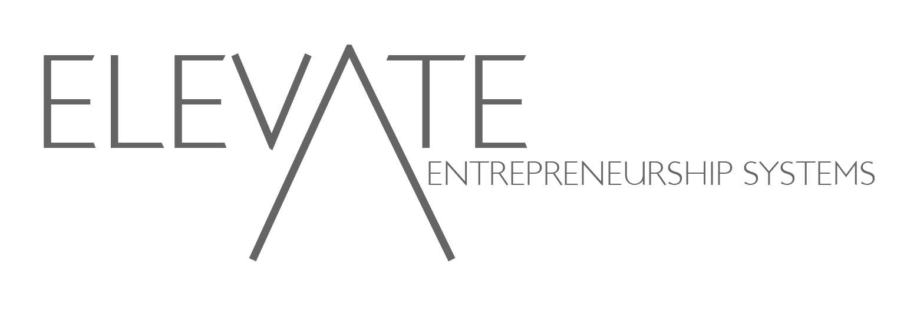Elevate Entrepreneurship Systems

Project M.O.S.T. Summer 2013

Entrepreneurship Institute

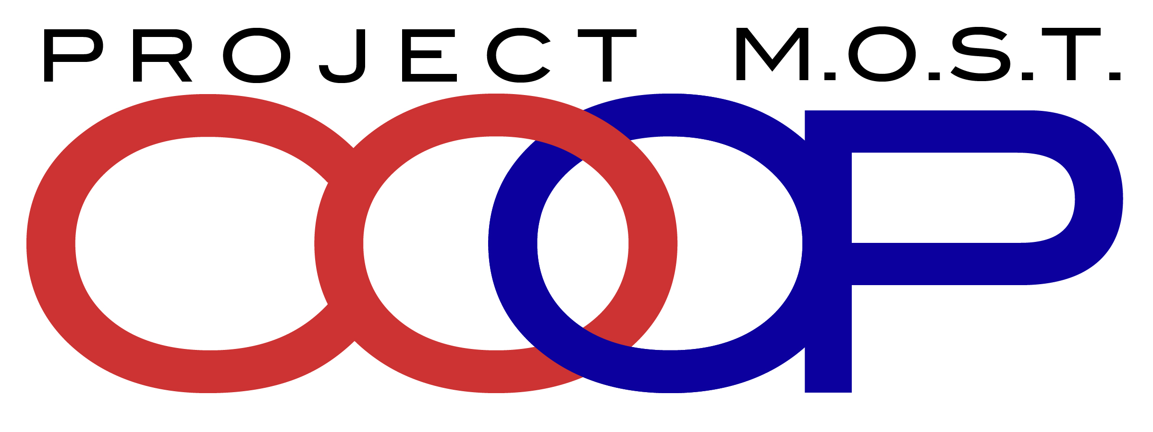FINAL PROJECT REPORT

# Training

**Emerge Tour / Accion Workshop / Micro-Lending**

The students of Project M.O.S.T. were able to experience a tour of the Emerge Memphis Incubator on June 6th of 2013. The incubator is one of Memphis’ most well known incubators for aspiring entrepreneurs. The M.O.S.T. Students had an opportunity to tour the facility. This tour was led by Carlton Crothers, CEO of Emerge Memphis. Mr. Crothers also sat down with each of the students in attendance and reviewed their individual business plans and talked to them about how to expand their businesses. Mr. Crothers also expressed interest in helping the students by providing possible office space, additional training workshops, and other special events at Emerge Memphis. [**http://www.bizjournals.com/memphis/print-edition/2013/06/07/emerge-gets-new-leader.html**](http://www.bizjournals.com/memphis/print-edition/2013/06/07/emerge-gets-new-leader.html)

The students also had an opportunity to network with Mr. Phil Trenary a well known successful entrepreneur from the Memphis Community who was the previous owner of Pinnacle Airlines a $1 Billion Dollar regional airline company**.** [**http://www.commercialappeal.com/news/2012/feb/29/pinnacles-ex-ceo-could-be-airborne-again/**](http://www.commercialappeal.com/news/2012/feb/29/pinnacles-ex-ceo-could-be-airborne-again/)

**Accion Micro-Lending Workshop**

Following the Emerge Tour Nathaniel Owen, Loan Manager for Accion Tennessee conducted a two hour workshop on micro-lending and Accion’s loan products. The students were able to understand how to complete a loan application, how to prepare to launch their businesses, and how to work with financial institutions to obtain financing. The students also had a chance to actually complete a practice micro-loan application with Mr. Owen’s Assistance.

**Micro-Loan Applications**

The Elevate Entrepreneurship Team worked with Project M.O.S.T. Students to complete online applications for micro-lending through Accion Tennessee. Ten students submitted applications. Many of the students had judgments, child support, and other civil actions that would not allow them to access micro-lending funds to support their start-up efforts. Currently MOST Music Group has completed the first phase of the micro-lending process and with a co-signer the group would have the ability to access $5,000.00Dollars through Elevate’s Student Micro-Loan Program. The Elevate Team will continue to work on recruiting this source of capital for the students. The Elevate Team also is working to develop a loan loss reserve account, which would help the students who have financial challenges obtain micro-financing through Accion.

**GoFund Me**

The Elevate Team also launched a crowd funding campaign for the students of Project MOST. This crowd funding campaign has been launched at the www.gofundme.com/projectmostcoop. The Elevate Team will work with the students and leadership of Project MOST to begin a promotions and outreach campaign to support the GoFundMe Campaign. Through this campaign Elevate will seek funding to support those student entrepreneurs who completed the training process.

**Memphis Power Tour**

The Project MOST Students had an opportunity to experience the Elevate Power Tour. This tour engaged the students in meeting with African American Entrepreneurs who started with humble beginnings. The students had a breakfast workshop with Levell Baltimore a 38 year old African American Male Entrepreneur who successfully grew his own landscaping company from one lawn mower to a multi-million dollar landscaping company that employed over 75 employees and that was sold to a large regional landscaping company. The students then met with the Memphis Chamber of Commerce, where they learned how to engage with the business community and local economic development groups, The students then had an opportunity to attend a bid opening with the City of Memphis, Purchasing Office; following the bid opening the purchasing office held a special workshop at City Hall for the Project MOST Students, and following those activities the Elevate Team provided these students with a debrief of the activities and encouraged each student to follow up with the contacts that they had gained during the day. Mr. Michael Cleveland had made contact with the Memphis Lights Water and Gas Company to schedule a meeting with the Chamber and the utility company to gain support for MOM Energy Auditors and Retrofitters.

**Federal Reserve Bank Financial Literacy Workshop**

On June 10th, 2013 the students of Project MOST experienced a financial literacy workshop held by the Memphis Office of the St. Louis Federal Reserve. The students were able to learn how to manage their finances, how to separate business revenue from personal income, and they also had an opportunity to learn about the many resources offered by the St. Louis Federal Reserve for entrepreneurial students.

**Business Bootcamp University of Memphis**

On June 22nd the Project MOST Students had an opportunity to participate in a business bootcamp led by Kelly Penwell. The business bootcamp was held at the University Of Memphis Center for Entrepreneurship and Innovation. Ms. Penwell provided the students with information on marketing, innovative new business plan models, and first hand experiences for entrepreneurs. The students had opportunities to network with other aspiring entrepreneurs and existing entrepreneurs. The students were able to connect with the University of Memphis. The University of Memphis also provided the students with the ability to earn up to 3 hours of experiential learning credits for participating in the boot camp. Currently Southwest Tennessee Community College/Project MOST and the University of Memphis are working on a plan to provide the students with credit at both schools for their participation in the boot camp and the intensive training that has been provided through this program.

**Pitch Practice / Public Speaking**

On June 27th the Project MOST Students had an opportunity to prepare for the business plan pitch competition. The students received 4 hours of intensive training on how to make an Elevator Pitch, how to address financial questions, confidence, proper attire, and how to deliver information on their companies. This pitch practice helped students understand the importance of effective communication skills, particularly when in a business environment.

**University of Memphis Business Plan Pitch Competition**

On June 28th the M.O.S.T. Students had an opportunity to participate in a business plan pitch competition. This competition provided the students with the opportunity to present their businesses in front of their peers, local business development groups, and to a panel of judges. The panel of judges graded the students based on their 3 minute pitches and 2 minute questions and answers. The students were evaluated based on creativity, ability to present, confidence, use of visual aids, reality of business concept, and overall quality of presentation. 5 awards were provided to students who delivered the best presentations. The students also had an opportunity to explore the University of Memphis Campus and learn more about the University’s commitment to entrepreneurship in Memphis.

# Outcomes & Recommendations

**Graphic Design / Video Production**

Elevate Entrepreneurship Systems recommends that Project MOST engage in the development of graphic materials and the editing of video from the summer activities. The organization has a great deal of visual materials that can be used to promote entrepreneurship and student success within the Project MOST Program. Elevate would be happy to submit a proposal for these services and to develop a sub-contractual relationship with student entrepreneurs from A. Talent. Of. MOST (ATOM) one of the companies that was developed by the student entrepreneurs.

**Entrepreneurship Library**

Elevate recommends that Project MOST develop an entrepreneurship library. This library would provide students with books, periodicals, web-links, and other digital resources aimed at helping students develop businesses. Project MOST will have a strong reputation as a resource for entrepreneurship following this training and these resources could be helpful in efforts to provide resources to students who are seeking to launch businesses.

**Immediate Start-Up Training / Incubation**

Elevate recommends that this contract be extended to provide additional training to the students who have completed the summer training activities. This training should focus on promoting the crowd-funding campaign, working to identify mentors for the student entrepreneurs who have completed, and identifying a physical place for student entrepreneurs to establish their businesses within the Memphis Community. Elevate recommends that Project MOST and the leadership of STCC develop an extension to the existing agreement and continue the development of the students who have completed the first phase of the training system.

**Fall Entrepreneurship Institute**

Elevate recommends that Project MOST develop a Fall Entrepreneurship Institute. This training institute should provide Project MOST Students with 24-30 hours of entrepreneurship training. This training would be implemented at the beginning of the fall semester. The training would be conducted on Fridays and Saturdays to accommodate student schedules.

**Fund Start-Ups / Fundraising Activities**

Elevate recommends that Project MOST work in partnership with Elevate to identify additional funding. The team will raise funds to support existing student businesses. This funding will also help to support student entrepreneurs who have completed the training. Elevate recommends that the team work together to organize fundraisers and special events dedicated to the development of the student businesses. Elevate also recommends that Project MOST and Elevate work together to identify a supplemental grant from local government agencies, foundations, and/or other funding organizations to support the development of this entrepreneurship system through Project MOST.

# Deliverables Chart / Completed Activities

|  |  |  |  |  |
| --- | --- | --- | --- | --- |
| **Payment** | **Amount** | **Phases / Components and Time Period** | **Deliverables** | **Actual Activities / Deliverables Completed** |
| Initial Payment | $7,500.00 | Start-Up  Workshop and Supplies  March | Complete Empowering Entrepreneurship Workshop  Student Workbooks / Educational Materials  Complete Education / Outreach campaign / Promotional Campaign | May 9th completed at Southwest Union Campus /  Delivered workbooks, and promotional poster May 14th during training session |
| Payment 2 | $5,000 | Entrepreneurship Training  (4 sessions)  April / May | Complete Four Training Sessions With Students | Training Launched May 13th, May 14th, and May 15th, and May 17th |
| Payment 3 | $5,000 | Summer Institute  May/June | Completion of Summer Institute (2 Week Intensive Training) | Training Completed  May 18th, May 20th, May 21st, May 22nd, May 23rd, and May 24th  Training Workshop Emerge Memphis Tour and Micro-Lending Workshop Thursday May 6th  Training Workshop and Power Tour (City Purchasing, Chamber of Commerce, Marriott Hotel / Levell Baltimore) Friday May 7th  Accion Loan Application Technical Assistance and Training Saturday May 8th  Financial Literacy Training Project MOST Office Monday May 10th |
| Final Payment | $3,750 | Final Activities  Business Plan Competition  Final Report  June | Complete Business Plan Pitch Competition  Complete Final Program Report  Complete and Submit Photos and Video of Program | Competition Completed at U of M 06.28.13  Final Report Submitted  Video and Photo Files Submitted |